Ysgol Bryn Castell

School Improvement Plan (SIP) Summary Document
2023-26
Year 3 of 3 2025/26

‘Together we can achieve …’

School improvement priorities:
Target 1: Health and wellbeing of pupils, staff and the community of YBC (Post Inspection Action Plan (PIAP) Recommendation 1 (R1))
Target 2: Plan, implement and deliver the Curriculum for Wales at YBC (PIAP R2)
Target 3: Responding to and embedding ALN reform and the continued growth of YBC

PM targets:
Teachers | To create a school community where everyone belongs by using PACE and other models to maximise pupil progression in literacy, numeracy and independence
Support staff | To create a school community where everyone belongs by using the PACE model alongside Team Teach and our Total Communication approach at Ysgol Bryn Castell

This document is published on the school website annually.
Index
Description | Page number
School context and vision | 3
The school improvement process at Ysgol Bryn Castell: Annual School Improvement Cycle | 5
What informs the SIP? | 6
Key Priorities for 2025/26 | 10
How will we achieve this? | 11

School Context and vision
Ysgol Bryn Castell (YBC) is a community day special school which provides education for pupils aged 7 to 19 years old with complex Behavioural, Emotional and Social Difficulties (BESD) including Autism alongside specific learning difficulties and other additional learning needs.
We are a caring, small school that is able to offer an independent package of support for pupils to enable them to achieve and enjoy their schooling. For many pupils, their admission to YBC can represent the start of a positive learning experience; which many pupils may not have encountered for a significant period of time. At YBC we encourage all pupils to get back into learning; we want them to take responsibility for their learning, and to become resilient, resourceful and reflective young people.
We want to create a school environment where children are safe and secure, where they enjoy their learning and have the opportunity to develop their talents. We want to provide a stimulating curriculum that encourages curiosity and values independent thought. All our staff are committed to these aims and continually strive to provide the highest quality education we can for our pupils. All staff value the quality of teaching and the strong pastoral care of our pupils and are dedicated to doing their best for all the children in the school. They look to develop a constructive relationship with Parents/Carers and other stakeholders so that we can genuinely work together to help and support all pupils to achieve their best: ‘Together we can achieve …’
Additional information can be found on the school website http://www.ysgolbryncastell.co.uk/.
The number of pupils that the school can accommodate has changed over time, and through ongoing discussions with the Local Authority, the number of pupils accommodated per class is no longer fixed and is linked directly to pupil need. The school currently has the following classes:
Department of school | Number of classes | Total number of pupils
Ogmore | 3 | 18
Candleston | 4 | 28
Dunraven | 6 | 42
Newcastle | 2 | 24
Coity | 8 | 64
Bespoke packages | N/A | 13
TOTAL | 23 (plus bespoke packages) | 189

Over half of the pupils at YBC are in receipt of Free School Meals (FSM); there are currently 65.7% of pupils who are eligible for FSM. The number of Children who are Looked After varies significantly over time; from 21 pupils in June 2016 to 16 in September 2025. 37.5% learners at YBC are open to services, including social services, in some capacity. Many young people have vulnerabilities around safeguarding; a number of high tariff young people require effective multi-agency working in order to ensure their needs are met 24-hours per day, 7 days per week.
The school has a high level of pupil admissions and variable pupil roll on an ongoing basis although as pupil numbers have risen and the school lacks capacity this has begun to stabilise. From 2022/23 onwards, the Local Authority worked towards reducing the admission points at the school to three times per year, other than in exceptional circumstances. This was partially achieved in 2023/24 with 67.6% of learners being admitted in September 2023 and was significantly improved in 2024/25 with 86.0% of learners admitted in September 2024 with other learners being admitted throughout the academic year.
All the priorities within YBC’s School Improvement Plan work towards achieving the national priorities and local themes as outlined within the Education and Family Support three-year strategic plan. YBCs aim for the 3-year school improvement plan for 2023 to 2026 is to achieve positive health and wellbeing for pupils, staff and the school community.
The school was inspected by Estyn in January 2019 and received the following judgements;
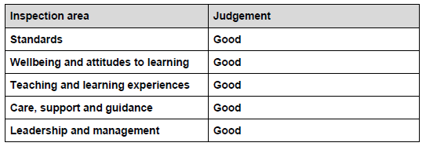
YBC was categorised as Green A school in 2016/17, 2017/18, 2018/19 and 2019/20.

The school improvement process at Ysgol Bryn Castell: Annual School Improvement
 | September | October |  |  |  | November |  | December |  |  |  | January |  |  |  |  | February |  |  |  | March |  |  | April |  |  |  |  | May |  |  | June |  |  | July |  | August
School improvement planning | Identify priorities for SIP | Consult on SIP with stakeholders |  |  |  |  |  |  |  |  |  |  |  |  |  |  |  |  |  |  |  |  |  |  |  |  |  |  |  |  |  | Staff SIP questionnaire |  |  | Identify priorities for SIP
School improvement planning |  |  |  |  |  |  |  |  |  |  |  | Review and update SIP |  |  |  |  |  |  |  |  |  |  |  |  | Review and update SIP |  |  |  |  |  |  |  |  |  | Review and update SIP
School improvement planning | >>>>> Implement SIP actions <<<<<
Self-evaluation (all stakeholders) | Update self-evaluation | Whole school self-evaluation activity |  |  |  |  |  | Update self-evaluation |  |  |  |  |  |  |  |  |  |  |  |  | Update self-evaluation |  |  |  | Whole school self-evaluation activity |  |  |  |  |  |  | Update self-evaluation
Self-evaluation (all stakeholders) | >>>>> Information and evidence gathering <<<<<
Self-evaluation (all stakeholders) | >>>>> Monitoring views of stakeholders including pupils, Parents/Carers, Governors, CSC, LA and multi-agency colleagues <<<<<
Professional learning | >>>>> Ongoing professional reflection and discussion <<<<<
Professional learning | Evaluate progress / set new PM  objectives |  |  |  |  |  |  |  |  |  |  |  |  |  |  | Review PM Objectives |  |  |  |  |  |  |  |  |  |  |  |  |  |  |  | Evaluate progress / set new PM  objectives
Professional learning |  |  |  |  |  |  |  |  |  |  |  |  |  | SLO survey |  |  |  | Continua review |  |  |  |  |  |  |  |  |  |  |  |  |  | Prepare draft PL plan including inset days
Professional learning | Set whole-school PM targets |  |  |  |  |  |  |  |  |  |  |  |  |  |  |  |  |  |  |  |  |  |  |  |  |  |  |  |  |  |  | Review progress with whole-school PM targets |  |  |  |  | Set whole-school PM targets
Vision and leadership | Summary SIP produced and published |  |  |  |  |  |  |  |  |  |  |  |  |  |  |  |  |  |  |  |  |  |  |  |  |  |  |  |  |  |  |  |  |  | Review school vision
Vision and leadership | >>>>> Ongoing participation in professional networks including SWASSH, CSC, Cluster, BASH and other networks <<<<<
Curriculum, learning and teaching | >>>>> Monitor Learning & Teaching <<<<<
Curriculum, learning and teaching | >>>>> Ongoing monitoring and review of curriculum <<<<<
Curriculum, learning and teaching | Planning share | Book look |  |  |  |  |  |  |  |  |  |  | Planning share |  |  |  |  |  |  |  | Book look |  |  |  |  |  |  | Planning share |  |  |  | Book look
Curriculum, learning and teaching |  |  |  |  |  |  | Parents evening |  |  |  |  |  |  |  |  |  |  |  |  |  |  |  |  |  |  |  |  |  |  |  |  | Report to Parents
Curriculum, learning and teaching | Consult with s’holders |  |  |  |  |  |  |  |  |  |  |  |  |  |  |  |  |  |  |  |  |  |  |  |  |  |  |  |  |  |  | Review curriculum |  |  |  |  | Consult with s’holders
Wellbeing, equity and inclusion | >>>>> Person centred planning and Individual Development planning <<<<<
Wellbeing, equity and inclusion | Motional |  |  |  |  |  |  |  |  |  |  |  |  |  |  |  |  |  |  |  |  |  |  |  |  |  | Motional
Supporting learner progression/shared understanding of progression | >>>>> External examinations <<<<<
 | National literacy and numeracy tests |  |  |  |  |  |  |  |  |  |  |  |  |  |  |  |  |  |  |  |  |  |  |  |  |  |  |  |  | National literacy and numeracy tests
 | Review pupil targets |  |  |  | Set pupil targets |  |  |  |  |  |  | Review pupil targets |  |  |  |  |  |  |  | Set pupil targets |  |  |  |  |  | Review pupil targets |  |  |  |  |  | Set pupil targets
 | >>>>> On going AfL <<<<<
 | >>>>> Shared Understanding of Progression <<<<<
 | >>>>> SWSSCCMN activities and involvement <<<<<
 | >>>>> Cluster activities and involvement <<<<<
Governing Body Accountability | Sub-committees of GB meet |  |  |  |  | HT report and scrutiny by full GB |  |  | Sub-committees of GB meet |  |  |  |  |  |  |  |  |  | HT report and scrutiny by full GB |  |  |  |  |  |  | Sub-committees of GB meet |  |  |  |  | HT report and scrutiny by full GB |  |  |  | Sub-committees of GB meet
Governing Body Accountability | >>>>> Ongoing dialogue with CSC, Estyn and LA <<<<<
Governing Body Accountability |  |  |  |  |  |  |  |  |  |  |  |  |  |  |  |  |  |  |  |  | Formula funding received |  |  |  |  |  |  |  | Set draft budget |  |  |  | Submit plans to LA
Governing Body Accountability | >>>>> Ongoing monitoring and review of budget including grants <<<<<

What informs the SIP?
Source | Targets
The school vision | Our vision is to enable our learners to experience success and make progress within a happy, safe, nurturing and healthy environment, where they are enabled to develop lifelong skills to prepare them for their futures.  All learners will experience fun, acceptance and happiness on their individual learning journey at Ysgol Bryn Castell. They will work with the school community to develop healthy relationships and experience broad opportunities for learning including through play and community-based education.  The school recognises that learners thrive and enjoy the best individual success and progress when the whole school community works together as one. Ysgol Bryn Castell actively involves Parents/Carers and the community in supporting learners’ health, wellbeing, learning and development.  We recognise that it is only by working together as a school community, as a YBC Family, that ‘together we can achieve’ the very best for our learners and enable them to celebrate their achievements and individual journey through our school.
The school values | 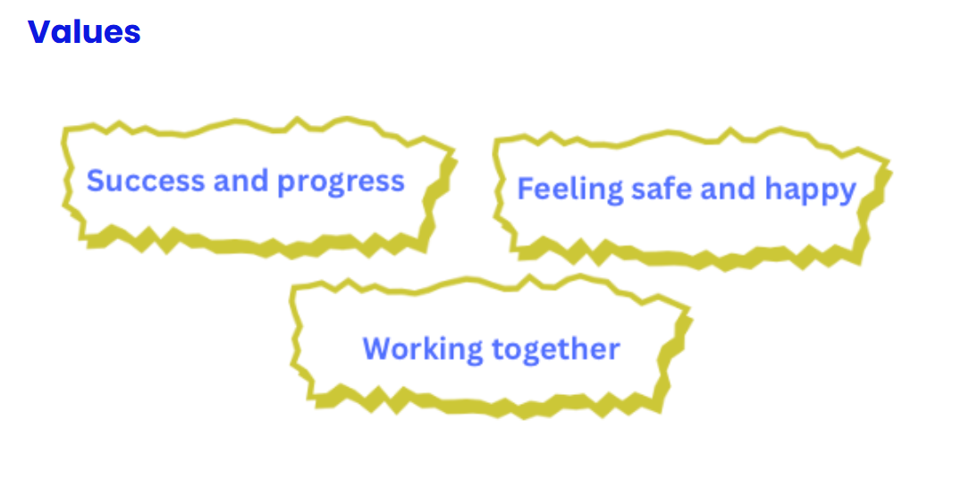
National priorities  [O1; O2; O3; O4; O5; O6] | Our national mission is to achieve high standards and aspirations for all by tackling the impact of poverty on educational attainment and supporting every learner.  Objective 1: Learning for life so that everyone in Wales learns, and continues to learn, developing their knowledge and skills, and engaging in experiences that are relevant to their lives today and into the future.  What we will do: Ensure that all learning is guided by the four purposes of the curriculum, through collaboration across providers and with industries and employers.  Objective 2: Breaking down barriers so that excellent education opportunities and outcomes can be achieved by all learners, at all ages, in classrooms, online, and in work.  What we will do: Through early identification, support and targeted actions, ensure that all learners gain the knowledge, skills and experiences to be an active citizen, including the cross-curricular skills of literacy, numeracy and digital competence.  Objective 3: A positive education experience for everyone, with learners and staff supported in their wellbeing and resilience, which is essential for improving education outcomes and life chances.  What we will do: Ensure that learners are supported to be healthy, confident individuals, ready to lead fulfilling lives as valued members of society, within places of learning that are supportive, safe, inclusive and free from discrimination and bullying.  Objective 4: High-quality teaching and leadership, where everyone benefits from the best professional learning so that they can support the success of all learners, particularly those who are socio-economically disadvantaged.  What we will do: Guaranteed career-long professional learning and support for all staff, from initial training through to leadership, focused on realising the four purposes of the curriculum, and capacity and capability to support the success of all learners.  Objective 5: Community-based learning, with strong institutions engaging, integrating and being empowered by their communities.  What we will do: Empower all learners, families and communities to build strong relationships and partnerships with education providers, so that we tackle disadvantage and deliver world-class education locally and nationally.  Objective 6: Cymraeg belongs to us all, giving every learner equal access to the language and the opportunity to reach their potential.  What we will do: Encourage the use of Welsh across the education system, as an integral part of Curriculum for Wales, our Cymraeg 2050 ambitions and expanding provision post-16 to study through Welsh and opportunities to learn the language as active and engaged citizens.
Pupil Deprivation Grant (PDG) | Tackling the impact of poverty on attainment is at the heart of our national mission in education. The Pupil Development Grant (PDG) has a key part to play in achieving this and we will build upon existing effective practice by ensuring that we target the funding as well as possible.  Estyn have stressed that schools which are effective in reducing the impact of poverty ensure that pupils have access to the very best learning and teaching, and that relationships are built with families, local communities, and specialist services.  To inform the use of the PDG in supporting these elements, guidance has been produced for schools on the most robust, evidence-informed approaches that they should consider using. This can be found at the following link: Pupil Development Grant: guidance | GOV.WALES.  Tackling the impact of poverty on attainment  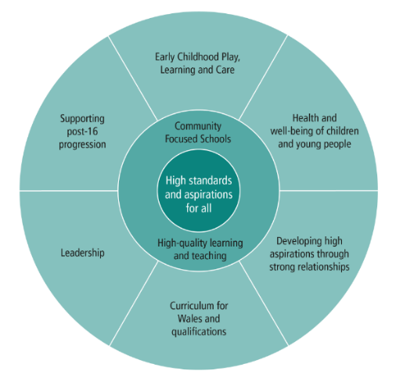  Overcoming educational inequality is complex. However, discussions held with practitioners and key stakeholders in the Welsh education system, as well as evidence from educational research, suggest that focusing on the following key areas should improve the attainment of children and young people from low-income households:  At Ysgol Bryn Castell, the school uses the PDG to support elements of the School Improvement Plan which are wide-ranging, focusing on a number of key areas and impacting on all learners at the school. The PDG is used to enable pupils to make individualised progress from their starting points, in a multi-agency, collaborative approach. As such, these integral areas of School Improvement which use PDG funding are detailed as such within the School Improvement Plan.  School Overview  Funding Overview
  Detail | Data
  School name | Ysgol Bryn Castell
  Number of learners in school at 12/11/2025 | 181
  Pupils in year groups 1 - 11 and eligible for free school meals | 110
  Date this statement was published | 12/11/2025
  Date on which it will be reviewed | 31/03/2026
  Statement authorised by | Governing Body
  PDG Lead | Helen Ridout
  Governor Lead | Ceri Finneral
  Detail | Amount
  PDG funding allocation this financial year | £105,800
  Total budget for this financial year | £105,800
Local priorities  [T1; T2; T3; T4; T5; T6; T7; T8; T9; T10; T11; T12; T13; T14; T15] | Bridgend County Borough Council’s Education, Early Years and Young People Directorate’s mission statement is:  To inspire and support children, young people, adults, and families to achieve better outcomes; leading to prosperous, healthy, safe, and happy communities  The directorate’s key deliverables are:  - sector-leading schools (supported by effective professional services) that provide outstanding learning opportunities to secure excellent outcomes for all learners;  - robust safeguarding procedures across all the directorate’s service areas;  - an ambitious School Modernisation Programme;  - excellent family support services delivered by the right people, at the right time, to those most in need;  - effective youth support services (including the provision of an appropriate youth justice service offer);  - a high-quality adult learning offer;  - an effective Welsh in Education Strategic Plan to promote the Welsh language and Welsh-medium education;  - outstanding support for children and young people with additional learning needs (ALN); and  - effective health and safety advice to all areas of council business.  The directorate’s key challenges include:  - the significant, continuing impact of COVID-19 (including pupil behaviour, attendance, and exclusions);  - budget pressures (particularly home-to-school transport and the school modernisation programme);  - curriculum and ALN reform;  - capacity issues (especially in specialist and statutory areas); and  - corporate health and safety compliance and monitoring.  National policy and local priorities  The Wellbeing of Future Generations (Wales) Act 2015 states that local authorities must work to improve the economic, social, environmental, and cultural well-being of Wales.  The Corporate Plan 2023-2028 and Medium-Term Financial Strategy (MTFS) 2023-2027 were approved by Bridgend County Borough Council (BCBC) on 1 March 2023.  The two documents are aligned to each other and make explicit links between BCBC’s well-being objectives, and the resources directed to support them.  Our national mission: High standards and aspirations for all’ (Welsh Government, 2023) (‘the national mission’) identifies a range of priorities to ensure the success, high standards and wellbeing of all learners.  This three-year strategic plan mirrors the aspirations of BCBC’s Corporate Plan 2023-2028 and closely aligns with the various policy drivers identified within this document.  Themes  Further to consultation with stakeholders and delivery partners, the Education and Family Support Directorate has identified the following 15 ‘strategic themes’ to underpin this three-year strategic plan:  T1 Pupil and staff wellbeing  T2 Support for pupil behaviour, attendance, and exclusions  T3 Support for vulnerable children and young people  T4 Support for children and young people with ALN  T5 Curriculum for Wales and assessment  T6 High-quality teaching and learning  T7 Effective leadership and governance  T8 Robust safeguarding procedures across all the directorate’s service areas  T9 Ambitious School Modernisation Programme  T10 Appropriate family support services delivered by the right people, at the right time, to those most in need  T11 Effective childcare and early years offer  T12 Effective youth support and youth justice services  T13 Meaningful adult in the community learning offer  T14 Effective Welsh in Education Strategic Plan to promote the Welsh language and Welsh-medium education  T15 Effective health and safety advice to all areas of council business (ensuring business resilience and continuity)  Education and Family Support Directorate Strategic Plan 2023-2026 (unitedgraphicdesign.com)
Estyn recommendations Jan 2019 | R1 Improve pupils’ attendance  R2 Ensure that all teachers have a clear understanding of pupils’ progress and their next steps for learning
Review of progress within previous SIP | See comments within 2023 – 2026 and overview below  2023/24:  - Admin restructure took place in Summer 2024  - Management Team restructure being considered  - Vision reviewed  - Department names reviewed  - Platinum IIF accreditation ongoing  - Capacity review completed  - Multi-sensory room installed  - Restorative approaches training delivered  - Professional Enquiry Groups undertook action research  - CAMHS SHINE service supporting school  - Termly coffee mornings for Parents/Carers  - New website developed  - Development of shared understanding of progression documents with Cluster and within school  - Improvements to the school environment  2024/25:  - Admin restructure fully populated  - Management Team restructure completed and fully populated  - Careers Platinum IIF accreditation achieved  - Installation of orchard into school grounds  - Introduction and appointment of Apprentice SSO model to the staffing structure  - Engagement with Quals Wales and preparation for new qualifications  - Review of the curriculum for learners  - Increased wellbeing opportunities for staff  - Behaviour policy thoroughly redesigned and rewritten  - Participation in regional groups to reduce behaviours that challenge and restrictive physical interventions  - Communication strategy introduced  - Online tracking tool ‘Tyfu’ implemented
Feedback from stakeholders | Ysgol Bryn Castell gathers the views of stakeholders throughout the school year, through focussed self-evaluation exercises, questionnaires and through: feedback@ybc.bridgend.cymru  The school consults with stakeholders annually on the School Improvement Plan in October and November.

Key Priorities for 2025/26
Target 1: Health and wellbeing of pupils, staff and the community of YBC
- Improve pupil attendance through targeted support and multi-agency collaboration
- Review and refine strategies and systems to support positive behaviour management at the school
- Embed Positive Behaviour Support (PBS)
- Work with colleagues both within and outside the school to review behaviour within a local and national context to reduce the impact of behaviours that challenge
- The impact of the music provision will continue to be evaluated and improved to impact in a therapeutic, curriculum and motivational manner on the maximum number of pupils
- Speech and language therapy to have an impact on all pupils at YBC
- Further implement trauma-informed approaches
- Strengthen emotional and mental wellbeing for pupils, staff and families
- Achieve Gold Rights Respecting Schools Award
- Enhance outdoor learning and forest school opportunities
Target 2: Plan, implement and deliver the Curriculum for Wales at YBC
- Continue to implement and refine the Curriculum for Wales across all departments
- Continue to improve the standard of teaching and learning at YBC
- Ensure that all teachers have a clear understanding of pupils’ progress and their next steps for learning
- Develop the YBC Pupil Passport
- Build on existing community engagement and partnership working to further broaden the opportunities for learners at YBC
- Continue to build and embed international links with other schools and partners
- Promote Welsh language and plurilingual experiences
- The offer of support for those learners who are most disengaged with formal learning will develop over time, working towards increasing engagement with learning
- Embed cross-curricular skills (literacy, numeracy, digital competence) and thematic learning
Target 3: Responding to and embedding ALN reform and the continued growth of YBC
- Fully embed Additional Learning Needs (ALN) reform and person-centred planning.
- Strengthen systems for Individual Development Plans (IDPs) and pupil documentation
- Review and refine evaluation and improvement in-line
- A more stable staffing position will have been achieved, including the addition of apprenticeships to the staffing structure
- Support staff development and wellbeing through professional learning
- Support the implementation of the leadership team and development of Middle and Senior Leaders at a local and national level
- Work with the Local Authority to manage admissions and capacity at the school
- Maximise the efficient use of the premises to accommodate pupil needs across BCBC

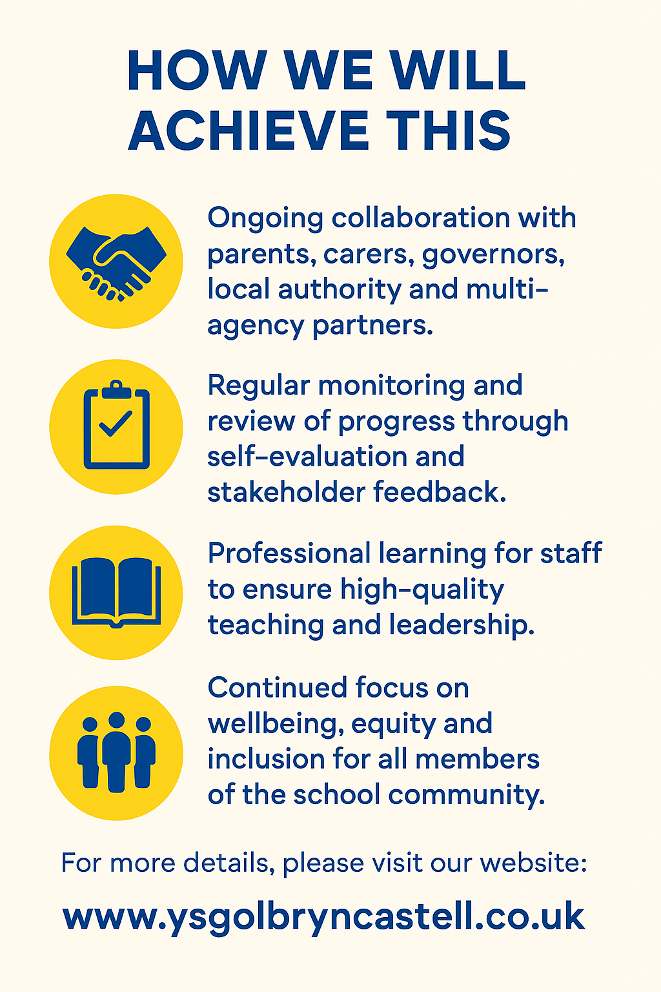
Please send any feedback for consideration to feedback@ybc.bridgend.cymru. We recognise that it is only by working together as a school community, as a YBC Family, that ‘together we can achieve’ the very best for our learners.

